Directions

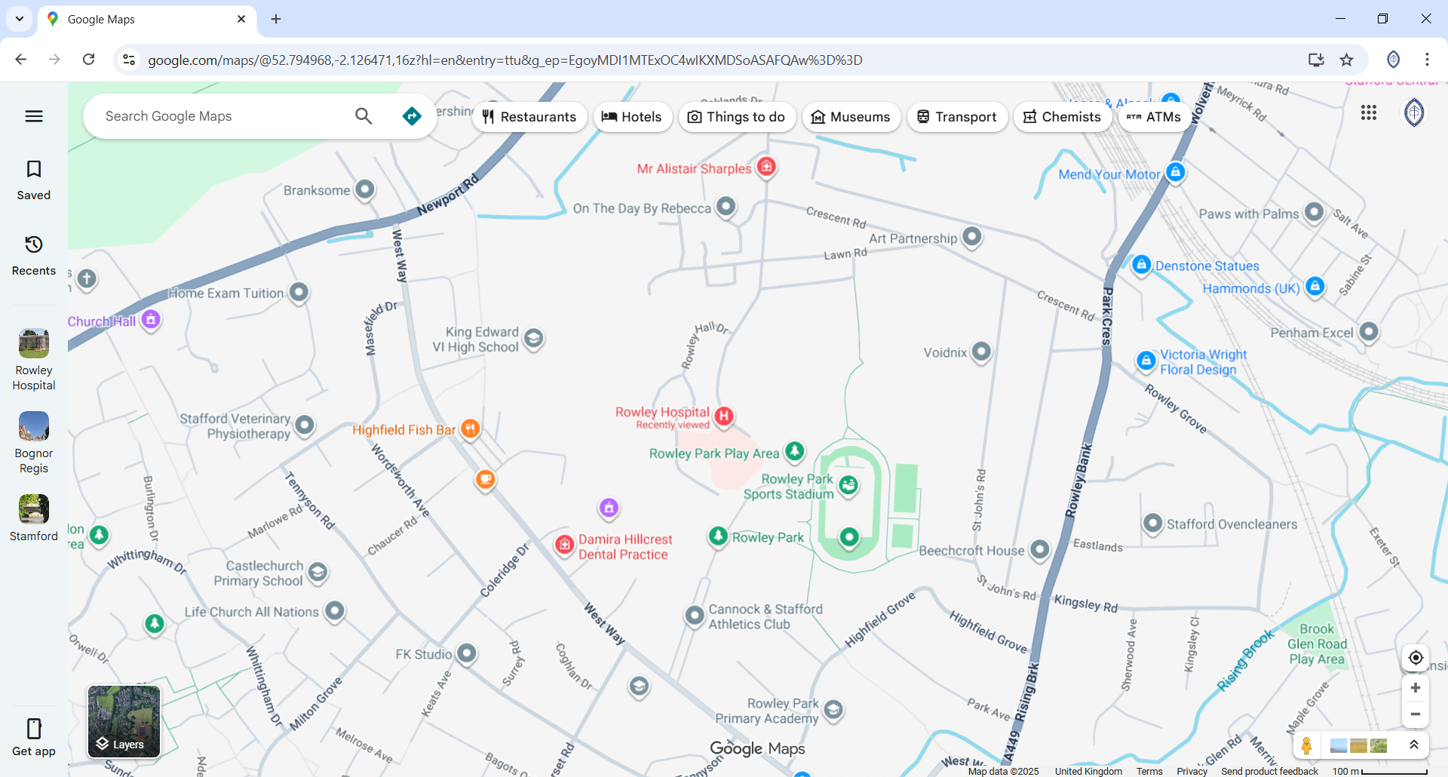

Directions to Rowley Hall Hospital
By Road
From A518 - Turn off onto Rowley Avenue (following signs for Rowley Hall Hospital). Follow all the way down until reaching the hospital.
By Train
Rowley Hall is just a ten minute walk from Stafford rail station. The station is served by Virgin Trains and London Midland and there are regular trains to London Euston, the Midlands and the North West including Birmingham, Stoke-on-Trent, Crewe and Liverpool.
By Bus
There are many bus routes to Stafford from across the region, from Birmingham in the South and Stoke-on-Trent in the North. Please click here for more information about bus routes and timetables.

